Schedule for LK0376, Advanced Digital Landscape Analysis with GIS, 15 credits
2023-12-05, NS
*Scheduled hours are those where a teaching activity or supervision is available. Course hours are from 09.00 to 16.00, with lunch between 12.00 and 13.00. It is expected that students be available for group work during course hours.
Activities highlighted in darker orange are on-campus only. Guest lectures may be either online or on campus depending on the speaker, this will be confirmed closer to the time.
Activities in bold are compulsory. This does not mean activities in plain font are “optional”!
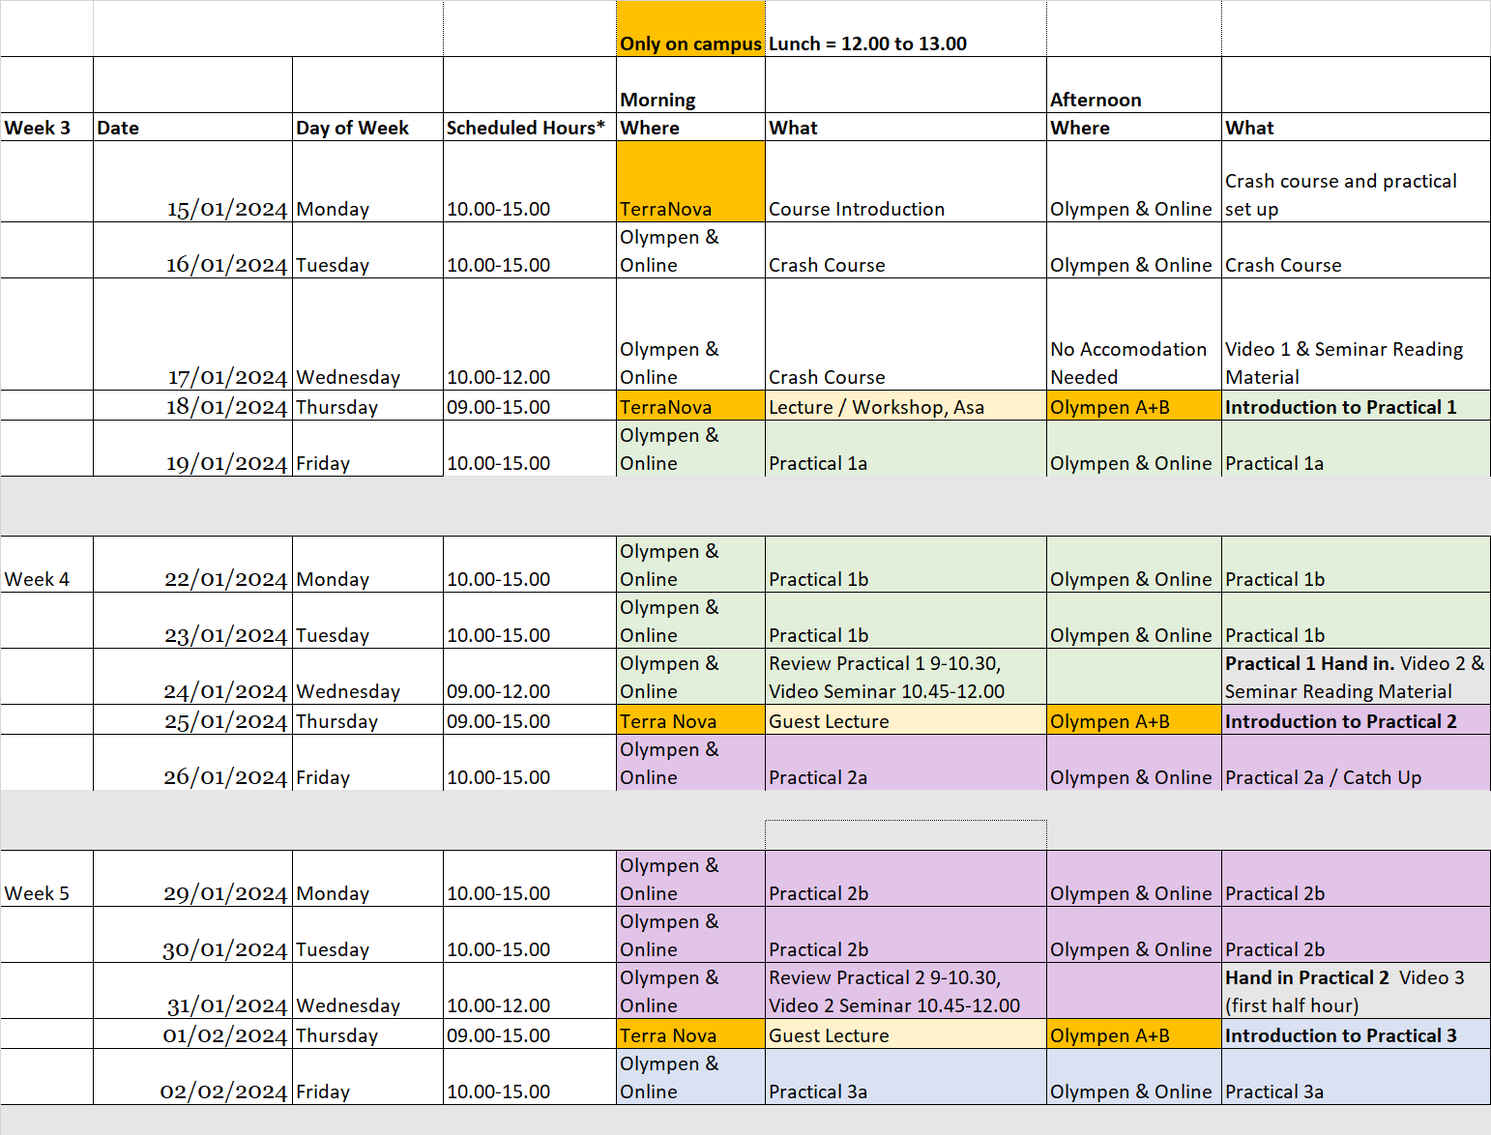
Page 1 of 2
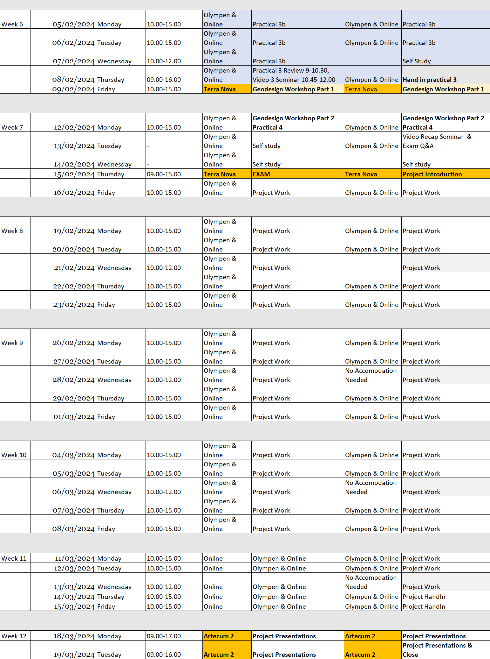
Page 2 of 2

