ADLA 2021 – Timetable*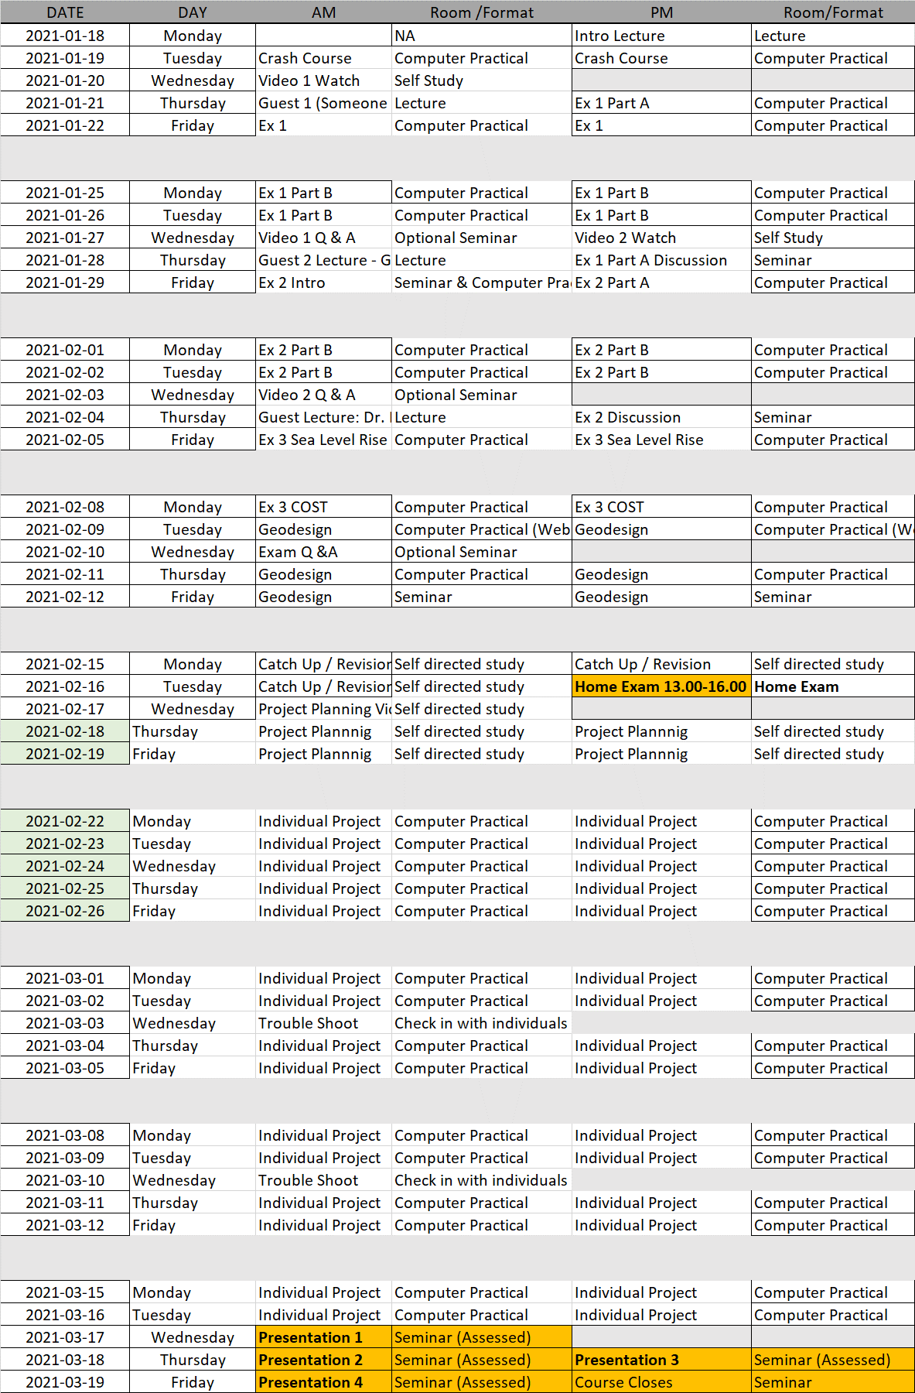
*Please note this timetable is likely to change in the event of Covid19 related issues. 1/2
Computers: All students on the course will have access to a computer on campus. Which computer rooms are available is still to be confirmed. Students who have access to a suitable computer and internet at home are encouraged to work from home if possible.
All supervision, lectures and seminars will be held via Zoom or Microsoft teams, there will be no face to face tuition.
The exam will be a home exam.
The presentations of the final projects form part of the assessment and will be carried out via zoom.
2/2

